**SCREENSHOTS FOR REFERENCE**

If you do it the way I did it, this is how your project will look. But I would advise you to get a little more creative and try making something different!!!

1. Initial Screen upon page loading looks like this. Click on screen to raise the curtain and unveil the goodness behind☺

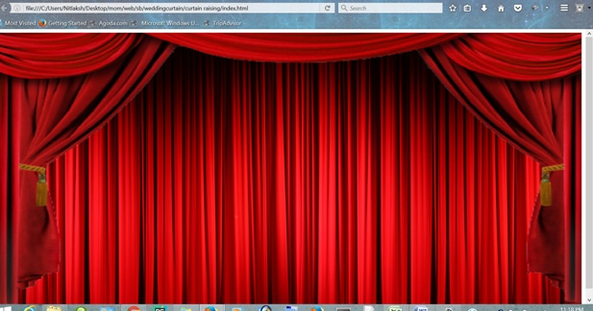

1. After Clicking on the screen, the hands are in this position (Don’t like the hands???? Well, don’t worry this is just an image I used for my project. Get creative and use some other pictures!!!)

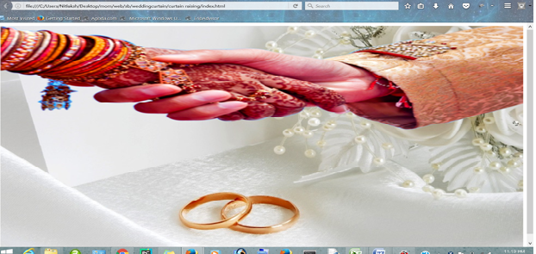

1. Upon clicking on the picture of the hands. You can try with this effect as well as many more effects with any image of your choice. (I have used photograph of hands of an Indian wedding couple for this project).

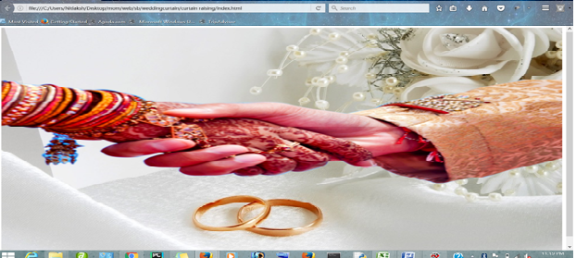

**ANOTHER VARIATION OF THE EFFECT**

1. When the curtain is raised, initial position of the text as well as the image.

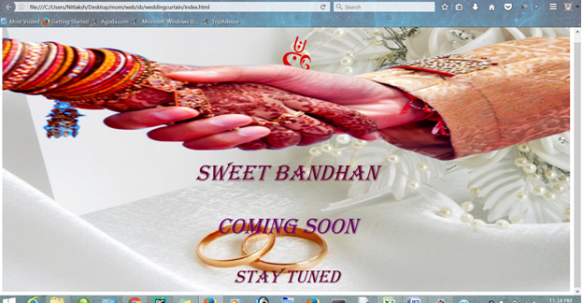

1. When we click on the hands, the logo is revealed.

